KEIL IDE
The µVision IDE from Keil combines project management, make facilities, source code editing, program debugging, and complete simulation in one powerful environment. The µVision development platform is easy-to-use and helping you quickly create embedded programs that work. The µVision editor and debugger are integrated in a single application that provides a seamless embedded project development environment. The Keil software is mainly used for the development and testing of a family of microcontrollers based on 8051 technology, like the AT89C51 / AT89S52 which we are going to use in our projects.
To create a project, follow the following steps:
- Open Keil and start a new project:
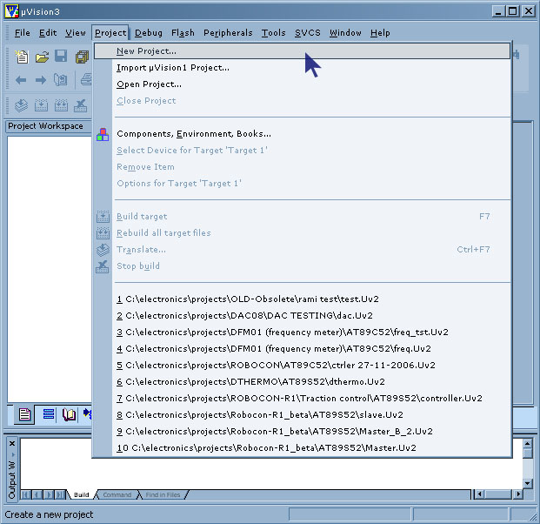
- You will prompted to chose a name for your new project, Create a separate folder where all the files of your project will be stored, chose a name and click save. The following window will appear, where you will be asked to select a device for Target 'Target 1':
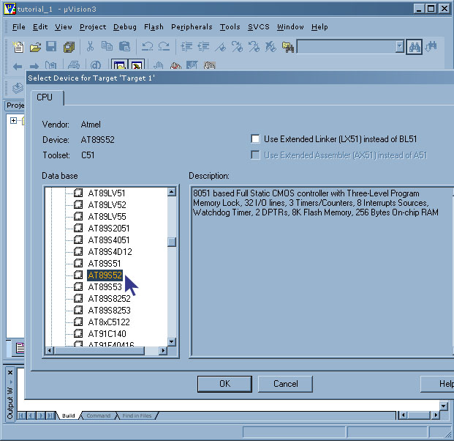
- From the list at the left, seek for the brand name ATMEL, then under ATMEL, select AT89S52. You will notice that a brief description of the device appears on the right. Leave the two upper check boxes unchecked and click OK. The AT89S52 will be called your 'Target device', which is the final destination of your source code. You will be asked whether to 'copy standard 8051 startup code' click No.

- Click File, New, and something similar to the following window should appear. The box named 'Text1' is where your code should be written later.
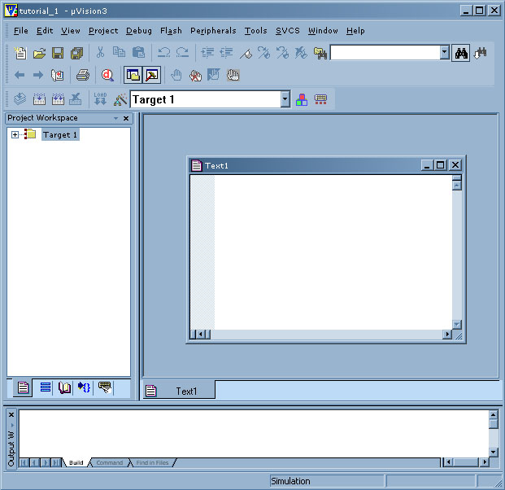
- Now you have to click 'File, Save as' and chose a file name for your source code ending with the letter '.c'. You can name is 'code.c' for example, and click save. Then you have to add this file to your project work space at the left as shown in the following screen shot:
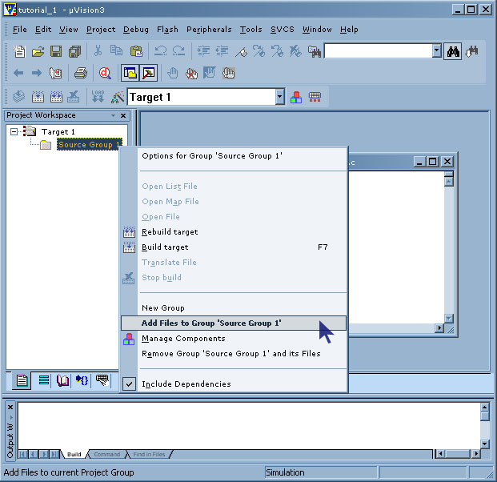
- After right-clicking on 'source group 1', click on 'Add files to group...', then you will be prompted to browse the file to add to 'source group 1', chose the file that you just saved, eventually 'code.c' and add it to the source group. You will notice that the file is added to the project tree at the left.

- In some versions of this software you have to turn ON manually the option to generate HEX files. Make sure it is turned ON, by right-clicking on target 1, Options for target 'target 1', then under the 'output' tab, by checking the box 'generate HEX file'. This step is very important as the HEX file is the compiled output of your project that is going to be transferred to the microcontroller.

- You can then start to write the source code in the window titled 'code.c' then before testing your source code, you have to compile your source code, and correct eventual syntax errors. In KEIL IDE, this step is called 'rebuild all targets' and has this icon: .
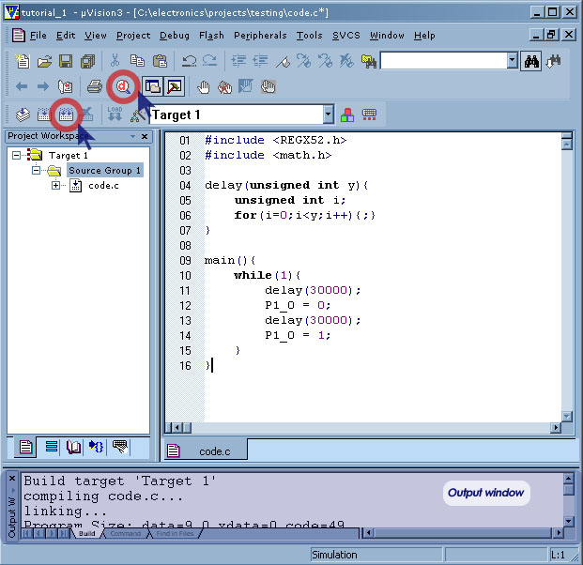
- You can use the output window to track eventual syntax errors, but also to check the FLASH memory occupied by the program (code = 49) as well as the registers occupied in the RAM (data = 9). If after rebuilding the targets, the 'output window' shows that there is 0 errors, then you are ready to test the performance of your code.

- In keil, like in most development environment, this step is called Debugging, and has this icon:. After clicking on the debug icon, you will notice that some part of the user interface will change, some new icons will appear, like the run icon circled in the following figure:
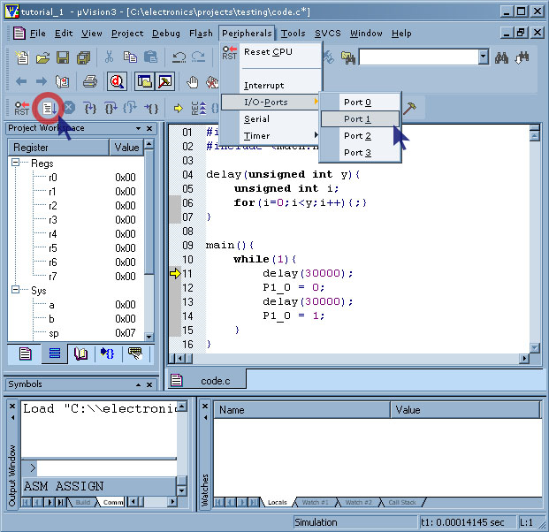
- You can click on the 'Run' icon and the execution of the program will start. In our example, you can see the behavior of the pin 0 or port one, but clicking on 'peripherals, I/O ports, Port 1'. You can always stop the execution of the program by clicking on the stop button () and you can simulate a reset by clicking on the 'reset' button ().

- You can also control the execution of the program using the following icons: which allows you to follow the execution step by step. Then, when you're finished with the debugging, you can always return to the programming interface by clicking again on the debug button ().

